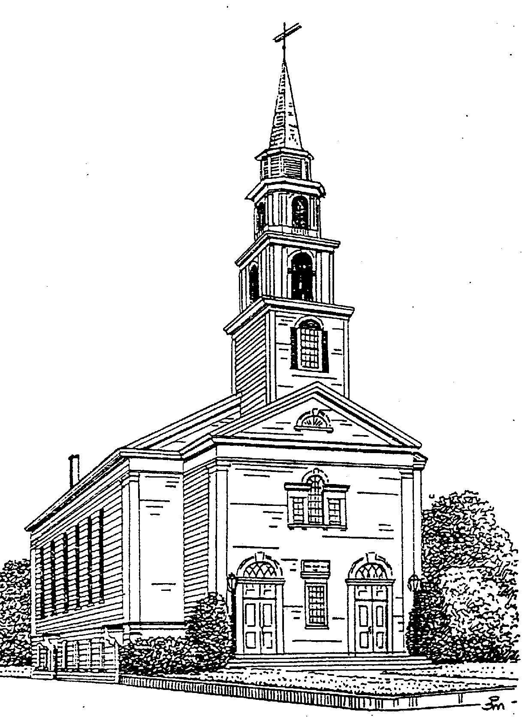First Congregational Church

United Church of Christ

4 Congress Street
P.O. Box 344
Milford, MA 01757
(508) 473-5259
www.milfordcongregational.org
office email: milfordcongregational@gmail.com

Organized 1741

Sunday School Registration
2024-2025
(Please fill out one form for each child)

Student’s Last Name: ____________________ Student’s First Name: ____________________

Student’s Date of Birth: __________________ Student’s School Grade: __________________

School Attending: _________________________________________________________________

Parent/Legal Guardian Name(s): _____________________________________________________

Student’s Primary Residence Address: ________________________________________________

Alternate Address, if applicable: _____________________________________________________

Home/Cell Phone: Parent/Caregiver: ________________________________

_____________________ Relationship: ____________________

_____________________ Relationship: ____________________

Email addresses: Parent/Caregiver: __________________________________________________

Sibling(s) Name, Age, Grade: ______________________________________________________

______________________________________________________

Health Issues

Are all immunizations up to date? ______ Yes ______ No Tetanus: ______ Yes ______ No
List any medications and dosages/frequency taken on a regular basis:

List any allergies:

List any conditions (medical or emotional) that are necessary for The First Congregational Church adult advisors/staff to assure the health and safety of this Youth:

I would like to volunteer my time by:

_____ Volunteering in the Crib room

_____ Substitute teaching

_____ Coordinating the Christmas Pageant

_____ Assisting with the Christmas Pageant

Photo/Video Release Form
I hereby give permission for images of my child, captured at First Congregational Church through video, photo and digital camera, to be used solely for the purposes of First Congregational promotional material and publications, and waive any rights of compensation or ownership thereto. Name of Participant (please print): ____________________________Age: ___________________
Participant (please print): ____________________________Age: ___________________
Participant (please print): ____________________________Age: ___________________

Name of Parent/Guardian (please print): ______________________________________________

Name: ______________________________________________________________________________

Phone: _______________________________ Email: ____________________________________

